

**FAR-WESTERN UNIVERSITY  
School of Engineering**

**Mahendranagar, Kanchanpur**

**Nepal**

[Subject code: CT-125]

**A MAJOR PROJECT PROPOSAL ON**

**"BILLING SYSTEM IN SUPERMARKET"**

Submitted By: Submitted to:

Bijaya Singh Saud [08] Er. Birendra Singh Dhami

Janak Singh Dhami [18] School of Engineering, FWU

Mamata Pant [24] Date: - 2079-02-04

Puskar Bhatt [36]

**Abstract**

This is a proposal report for the project on the "BILLING SYSTEM IN SUPERMARKET". In this proposal we have included all the types of requirements for the project report, all the features, applications, of the project. This project is actually digitalized billing system or in most commonly paperless billing system. Paperless billing system is a process that businesses can use it to get paid quickly and securely without dealing with the hassles of paper bills and check payments.

Paperless bill allows bill delivery and payment to take place completely online which improves efficiency while reducing costs.

Key words: Billing, Supermarket, Paperless billing.

**ACKNOWLEDGEMENT**

In performing our assignment, we were given the help and guideline of our teachers and seniors to whom we extend our sincere gratitude. We would also like to thank our Lecturer respected sir Er. Birendra Singh Dhami for giving us the opportunity to work on the project. I would like to express my gratitude and appreciation to all those friends associated to our project. Without their continuous support and encouragement, it would have never been possible for me to work at a project. We would also like to expand our deepest gratitude to all those who have directly and indirectly guided us in this project.

BE Second Semester

**TABLE OF CONTENT**

ABSTRACT …………………………………………………………………………………………………………………….. i

ACKNOWLEDGEMENT ……………………………………………………………………………………………………ii

LIST OF FIGURES …………………………………………………………………………………………………………. iv

CHAPTER 1: INTRODUCTION………………………………………………………………………………………...1

* 1. Background………………………………………………………………………………………………………….…1
  2. Problem Statement………………………………………………………………………………………………..1
  3. Objectives………………………………………………………………………………………………………….…..2
  4. Applications………………………………………………………………………………………………………….…2
  5. Project features………………………………………………………………………………………………………2
  6. Feasibility Analysis………………………………………………………………………………………………….2
     1. Technical Feasibility……………………………………………………………………………………….…2
     2. Economical Feasibility……………………………………………………………………………………… 3
  7. System Requirement………………………………………………………………………………………………3
     1. Hardware requirement……………………………………………………………………………………..3
     2. Software Requirement………………………………………………………………………………………3

CHAPTER 2: LITERATURE REVIEW………………………………………………………………………………..4

2.1 Project………………………………………………………………………………………………………….……….4

2.2 Billing ………………………………………………………………………………………………………….……..4

2.2.1 Paperless Billing……………………………………………………………………………………………4

2.3Conclusion ………………………………………………………………………………………………………….7

CHAPTER 3: METHODOLOGY…………………………………………………………………………………….8

3.1 System Development……………………………………………………………………………………………8

3.2 System Design…………………………………………………………………………………………………….8

CHAPTER 4: EPILOGUE…………………………………………………………………………………………..10

4.1 Expected Output……………………………………………………………………………………………….10

4.2 Budget Analysis………………………………………………………………………………………………..12

4.3 Work Schedule…………………………………………………………………………………………………12

REFERENCES

**LIST OF FIGURES**

FIGURE PAGE

Figure 3.1…………………………………………………………………………………. 9

Figure 3.2………………………………………………………………………………….9

Figure 4.1………………………………………………………………………………….10

Figure 4.2………………………………………………………………………………….11

Figure 4.3………………………………………………………………………………….11

Figure 4.4………………………………………………………………………………….11

**CHAPTER 1: INTRODUCTION**

* 1. **Background**

In the field of Computer and Engineering "Project" means a program that is used to perform a specific task related to different technological fields. Project may be of different types such as solo project, mini project, group project, etc which are categorized on the basis of the size of project, member involved in project. This project is a group project which is also a program that performs certain tasks during paying bill in different places such as in supermarket, departmental stores, online shopping, shopping malls, etc. The title of our project is "Billing System ". As name tells everything, this project has so many features, applications, objectives, feasibility, etc.

The project "Billing system" is a project to automate the process of ordering and billing of a "Departmental store". This project is designed to make bill online. The current system regarding bill payments currently is done in such a way that utilities companies or service providers provides paper bill to their customers for payments. This project is made for making online bill instead of paper bill or sheet bill which helps to reduce the excess use of papers and save money that are spent by a company or a store in making paper bills. This system is more effective and cheap as compared to the paper billing system. In this project we make a billing project is such a way that it can hold or store the codes of products, name of the products price of the products, discount on the products. If anyone once to purchase products from the store then he/she can by any number of different products.

* 1. **Problem statement**

In the existing system all the persons work was done manually. They pay the bills on counters. The manual work processes was time consuming and hence slow. Following are the main drawbacks of the existing system:

* The existing system is totally manual thus there are chances of error in processing.
* The basic and major drawbacks in the existing system are the speed of retrieval of data from files, which leads to delay.
* Maintenance of voluminous data is very cumbersome and laborious job.
* The manual jobs such as calculation are more error prone.
* There are plenty of chances of duplicity of data and information.
* There is no central database from where one can get different statistical data at one place.

The above facts, figures and drawbacks clearly indicate that there is need for computerization and thus decided to computerize the Online Bill Payment System. Since the existing system was totally manual which has lots of complexities, shortcomings in itself and all the data was being stored in resister, files etc thus to overcome the limitations of the existing system, the new computerized system was needed, so that information can be provided to the user or customer more quickly, easily and more accurately.

**1.3 OBJECTIVES:**

* To add the details about the products.
* To edit the product details.
* To make bill for customer who purchase products.
* To make the billing system economically feasible.
  1. **APPLICATIONS**

The following are the main applications of the project

* This project applicable in departmental stores.
* In shopping malls
* In supermarket
  1. **PROJECT FEATURE**

Following are the features of project

* It saves time.
* It provides accurate and faultless in billing calculations.
* It saves money.
* It excludes the use of papers or sheet in making bills .
* Easy to operate and understandable.
  1. **FEASIBILITY ANALYSIS**

The feasibility study is carried out to test whether the proposed system is worth being implemented. Feasibility study is a test of system proposed regarding its work ability, its impact on the organization ability to meet user needs and effective use of resources. It is usually carried out by a small number of people who are familiar with the information system techniques, understand the part of the business or organization that will be involved or effected by the project and are skilled in the system analysis and design process.

The key consideration involve in the feasibility are:

* Technical feasibility
* Economic feasibility
* Operational feasibility
  + 1. **Technical feasibility**

This project is technically feasible due to following reason:

1. It is platform independent
2. Easy to deploy and maintain.
3. It can be modified as per our requirement.
4. Technical requirements are available (i.e. Software and Hardware)
   * 1. **Economical Feasibility**

Our system has a lot of features at a minimum cost i.e. costless so it is feasible to implement and it will be very much beneficial to the customer as well as service providers in reduced cost. In paper billing the costs of only bills also very high as compared to online billing system. Its hardware and software cost is almost zero. So the system that we are going to make is economically feasible.

* 1. **SYSTEM REQUIREMENT**
     1. **Hardware requirements:**

Intel based processor-run computer system, which have keyboard and mouse as input devices. This has been decided for its case of availability and up-gradation. The various registers maintained at the different department have enough information recording, which will help in digitizing the available data.

* + 1. **Software Requirement:**

**Front End**

1. Language used: C++. We use this language is supports event driven programming feature.

**Back end**

Required Software: Visual Studio Codes (VS Code)/Code Blocks.

Supporting Software: Visual Studio Code (VS Code), Code Blocks, Dev C++,, Turbo C++ etc.

**CHAPTER 2: LITERATURE REVIEW**

**PROJECT:**

Simply, a project is a series of tasks that need to be completed to reach a specific outcome. A project can also be defined as a set of inputs and outputs required to achieve a particular goal. Projects can range from simple to complex and can be managed by one person or a hundred. Projects are often described and delegated by a manager or executive. They go over their expectations and goals, and it's up to the team to manage logistics and execute the project on time. Sometimes deadlines can be given. For good project productivity, some teams break it up into individual tasks to manage accountability and utilize team strengths.

**BILLING:**

Billing is the process of providing a receipt containing all the details about the products that are bought by a customer from a mall or any other shopping store. Billing mainly contains the details of the product with their prices, discount and VAT on each product. By using billing system the sales of fake products, low quality products can be minimize. If we buy some food material or daily usable product from an shop and we didn’t demand for the bill or receipt of the materials then we may be cheated by them because we don’t have any proof to prove them they are selling low quality product or fake products which are harmful for not only human health but harmful for all the other animals.

As for example if we buy some medicine for a patient from a medical store, if we forget to take bill from the store and the use of medicine may affect the patient badly then we cannot blame to the medical store that they sold such medicine. So these days billing is more important.

There are two types of billing i.e. Paper billing and paperless billing.

**PAPERLESS BILLING:**

Paperless billing, also known as e-bill, is when a customer receives an electronic bill rather than a paper bill in the mail. These paperless bills are typically emailed to customers and available within their online accounts to access and review. Many customers can set up automatic payments through e-billing.

Benefits of paperless bill:

Paperless billing is a convenient way for customers to access, pay and store their bills. Furthermore, e-billing allow customers to pay their bills directly online, rather than needing to mail a payment or travel to a customer service center. It also allows customers to have easy access to their billing history without the paper clutter at home.

There are numerous advantages of paperless billing, including:

* On-the-go convenience
* Pay anytime, anywhere
* Saving money on stamps and envelopes
* Reduced carbon footprint
* Security
* **On-the-go convenience**

For energy utility customers, convenience is perhaps the number-one reason to enroll in [**paperless billing**](https://www.questline.com/blog/energy-utility-bills-paperless-advantage/). Instead of waiting for a paper bill in the mail, customers can quickly access their bill from their email inbox. Paperless billing fits into customers’ busy 24/7 schedules and helps reduce stress.

* Flexible payment options add to the convenience. Ebill customers have access to numerous [**payment options**](https://www.questline.com/blog/tips-enhance-ebill-communications/), including through a bank account, debit card, credit card, auto pay, mobile app and even smart home voice activation. When thinking about their bills, [**consumers say**](https://www.fiserv.com/en/about-fiserv/the-point/eighth-annual-billing-household-survey-getting-at-the-need-for-speed.html) late payments are a top concern. That’s why energy utilities should promote the benefits of email and text payment reminders in their paperless marketing.
* **Pay anytime, anywhere**
* The ability to access your bill from any location is a top benefit of paperless billing. According to Quest line’s [**Energy Utility Benchmarks Report**](https://www.questline.com/benchmarks/), 68% of residential customers engage with program promotions on a mobile device such as a Smartphone or tablet.
* A survey of Smartphone owners finds 42% pay their monthly bills through a mobile device. In addition, millennial and consumers with a household income between $50,000 and $99,000 are more likely to use mobile bill pay. As this data demonstrates, energy utility customers want the flexibility of viewing and paying their bill on the go.
* The COVID-19 pandemic aided in this “pay anytime” value proposition as consumers looked to budget their bills amidst other financial concerns. Instead of emphasizing the on-the-go benefits, highlight the 24/7 convenience of paperless billing. For example, customers can pay their bill in the middle of cooking dinner, doing a home work out or watching Netflix.
* **Saving money**
* For business customers in particular, paperless billing has a major impact on operational costs. Compared to residential consumers who receive about 12 bills total each month, small businesses receive about 50 bills [**on average**](https://chiefexecutive.net/how-e-billing-can-save-business-time-and-money/).
* Traditional paper bills require a constant supply of postage and envelopes or time spent logging into numerous sites to make payments. For small and large businesses alike, paperless billing reduces costs and increases productivity. With an overload of paper transactions in everyday business operations, electronic bill statements are one less piece of paper to keep track of each month.
* **Reduced carbon footprint**

There are numerous environmental reasons to go paperless, the biggest being a reduced carbon footprint. Energy utility customers are increasingly concerned about the environment, particularly younger generations. Research finds 68% of millennials purchased a product with an environmental benefit in the past 12 months.

Paperless billing gives customers an opportunity to help the planet, while also showcasing your energy utility’s efforts to reduce its environmental impact. In fact, 87% of consumers [**view a company favorably**](http://www.forbes.com/sites/forbesnycouncil/2018/11/21/do-customers-really-care-about-your-environmental-impact#773bbb3d240d) that supports the environment, whether through programs, products or philanthropic efforts.

* To reach the eco-conscious consumer, emphasize the sustainable benefits of going paperless, including less paper waste and a reduced carbon footprint. Paper is a [**major concern**](http://www.theworldcounts.com/stories/Paper-Waste-Facts), making up 25% of landfill waste, 33% of municipal waste and 50% of business waste. The environmental reasons to go paperless are growing increasingly important to promote.
* **Security**
* When it comes to paperless billing benefits, a top priority for many customers is security. How is their information stored? What will it be used for? Will their account be safe? Although digital methods can present their own concerns, the truth is that paper statements are not free of fraud risk. Mail can be intercepted, misplaced or fall into the wrong hands, leaving valuable account information or even payments unprotected.
* Paperless billing, on the other hand, accounts for these concerns by implementing security measures and protocols for customers’ login information. Even if bills or account information is emailed, it will never contain full account information, which gives extra protection if a customer’s email was to be compromised.
* It’s important to share how your utility puts security measures in place and the lengths it goes to protect customers’ sensitive data. Customers want transparency, especially when it comes to their personal information.
* [**Fiserv**](https://www.fiserv.com/en/about-fiserv/resource-center/consumer-research/2020-expectations---experiences--consumer-payments.html) surveyed respondents on the security of payment methods and found that consumers’ confidence in the security of specific digital channels, including financial mobile apps and digital wallets, increased significantly from 2018 to 2019. This highlights a move forward as customers acknowledge the safety of e-billing and grow more comfortable with the technology.

## CONCLUSION

In conclusion, this 2021 Supermarket Billing Project in C++ with Source Code can be beneficial to students or professionals interested in learning the C++ programming language. This project can also be customized to meet your specific needs. I hope that this project will assist you in honing your talents.

This is how you make a C++ Supermarket Billing in your projects. In your C++ projects, you can always expand and attempt alternative ways to implement the Supermarket Billing Project in C++. This Mini Project for Supermarket Billing Project in C++ with Source Code is free to download and use for educational purposes only. It is simple to comprehend and manipulate.

REFERENCES:

1. <https://sourcecodehero.com/supermarket-billing-project-in-c-with-source-code/>
2. <https://www.questline.com/blog/top-reasons-customers-choose-paperless-billing/>

**CHAPTER 3: METHODOLOGY**

**3.1 SYSTEM DEVELOPMENT**

The project billing system in supermarket is made for perform several tasks using the concept of C++ programming language. These types of billing system are economically cheap, time saving. In this project we uses different concepts such as class, object, functions (Having return type and void type),data hiding, encapsulation, looping such as for, while and do while loops, control statements, switch case statements and many more.

There are several different classes inside the program which have their own function and data members, several functions which perform different tasks and many more. This project includes almost all the features of Object Oriented Programming (OOP).

As we discuss about the implementation of the project after completion , it cannot only used in supermarket but also in Departmental stores, Normal Shops, shopping malls and so many other places too from where customer use to purchase products as per their requirement.

**3.2 SYSTEM DESIGN**

This project is designed in such a way that it possesses so many features related to management system of product details. This project will allow the owner or admin to add the product details, change the price, name and product code as per requirement. This project is designed to get the total knowledge of C++ in one program and also to make the billing system efficient.

Some pictures of codes that show how the concept of different topics are implemented to build the project are as given below which are helpful to know about the flow of program.

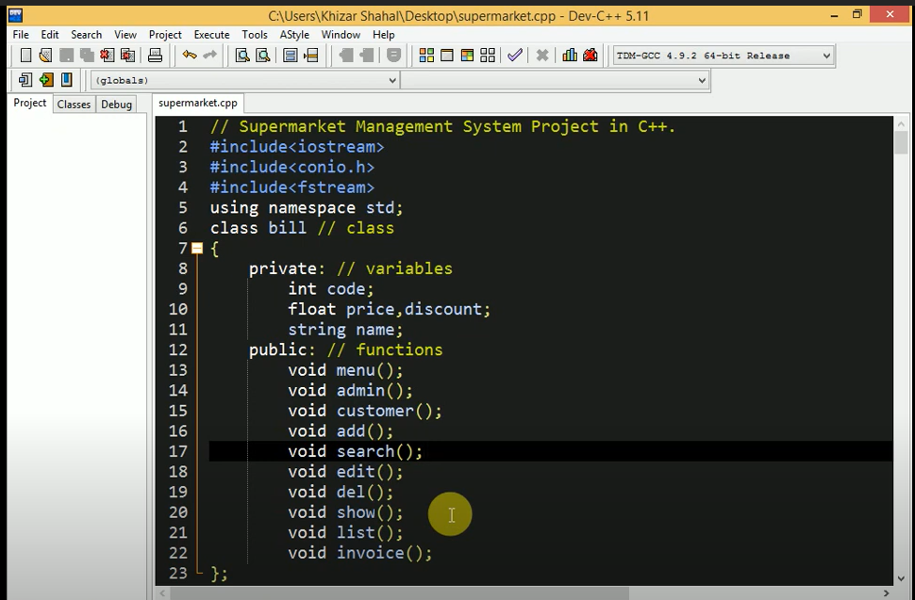

Figure 3.1: Declaration of functions.

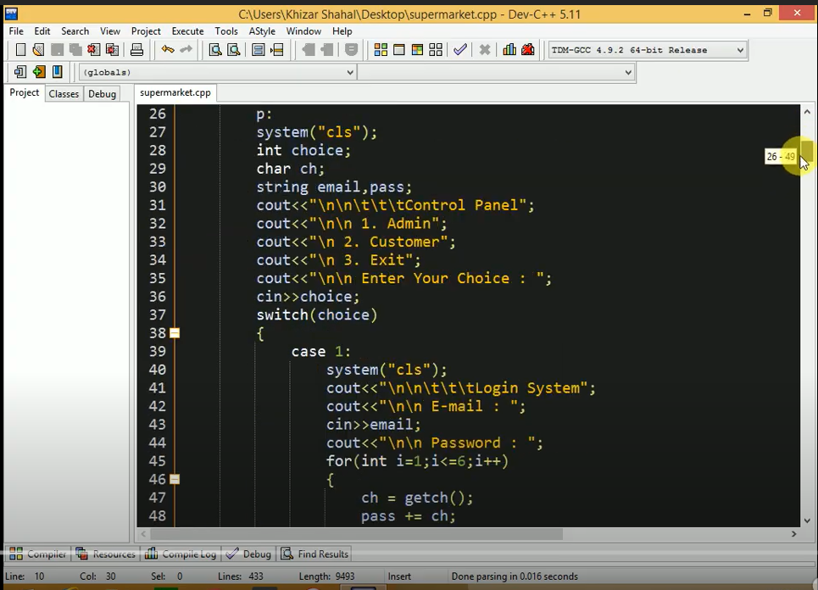

Fig 3.2: Switch Case Statements

**CHAPTER 4: EPILOGUE**

**4.1 EXPECTED OUTPUT**

The following are the main expected outputs of the project.

1. It must show control panel which is used either to login as admin or buy products as a customer.
2. It must show admin panel to add/search/edit/delete/show details of the project and also asks admin to their choice.
3. It must allow the admin to add/search/edit/delete/show product details.
4. It must asks for the product details as product code, Name of the product, price of the product as well as discount that admin wants to provide on each product individually.
5. It must allow the admin to see the added product details.
6. It should allow the admin to change the details of the product and remove product.
7. It should show details to the customer so that customer can easily analyze the rates, discount and other details of the product and also allows the customer to place their order.
8. It should show a receipt which contains quantity of the product (individual and total) total amount to be paid, amount paid and change return to the customer after placing the order.

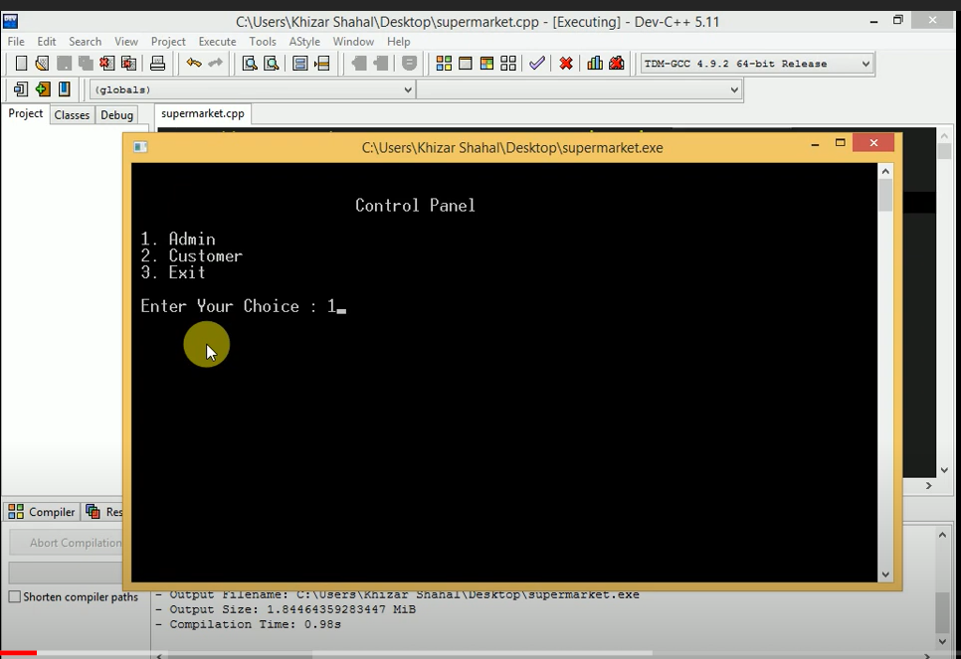

Fig 4.1: Output first (Control Panel)

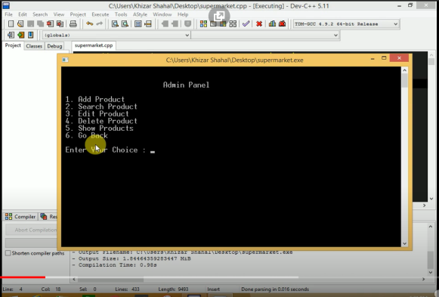 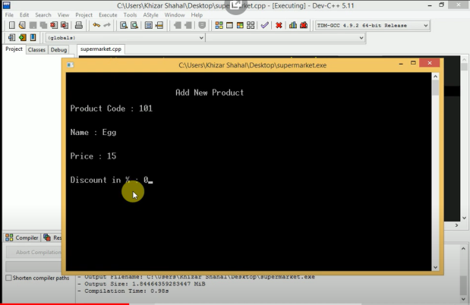

Fig4.2: Admin Panel Fig 4.3: Add new product section

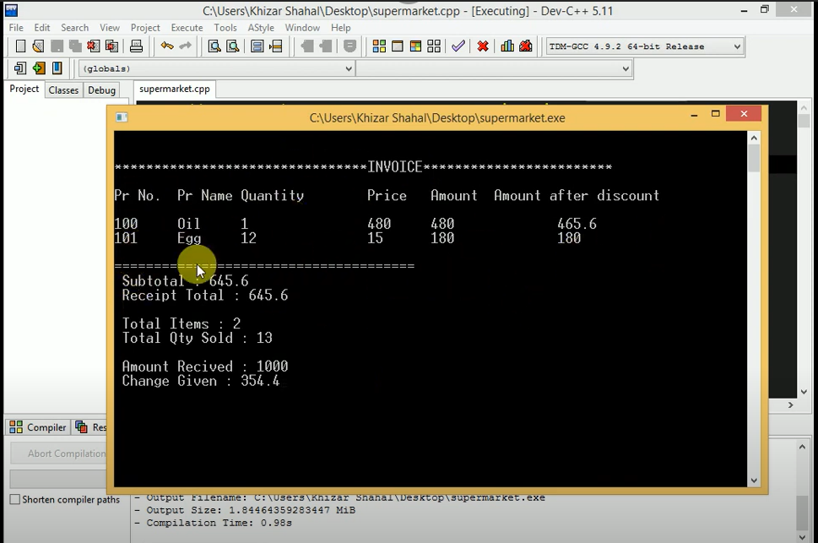

Fig 4.4: Final Receipt

**4.2 BUDGET ANALYSIS**

As our project is just a normal project that helps us to enhance the knowledge about different topics included in the Object Oriented Programming language. The main aim of this project is to make us a large program using almost all the concept of C++ such as class, functions, and objects etc.

This project is designed without any cost because it is made to learn something in the field of coding not designed for business purpose.

**4.3 WORK SCHEDULE**

Fig 4.1: Gantt chart

0 3 6 9 12

Days

Designing

Coding

Testing and Debugging

Documentation and Report

Research

**REFERENCES**

1. <https://sourcecodehero.com/supermarket-billing-project-in-c-with-source-code/>
2. <https://www.questline.com/blog/top-reasons-customers-choose-paperless-billing/>
3. <https://youtu.be/kOoaS8e2nBg>